**Problem Statement.**

A Card Player wants to know the probability about for the card pickup from the cards (**Considering only** **Hearts from 1 to 10**) and randomly pics the cards from the deck and wanted to know the sum of the 3 cards picked will be greater than 35 or not. If card sum is more than 20 he will get 5$ for each sum above 20, It has decided to simulate the deck for 500 times how much money can make?

**Model.**

Monte Carlo Simulation means using a computer to repeatedly carry out a random experiment and keeping track of the outcomes. In the example, we are trying this random experiment for 500 times to simulate this case we are generating the Monte Carlo Simulation. The only assumption with the model is the cards is limited to hearts and from considering Ace as 1 to 10. Jack, Queen, and King has been excluded from the calculation as there is no definite value for them.

Monte Carlo Simulation involving the use of random sampling techniques and often the use of computer simulation to obtain approximate solutions to mathematical or physical problems especially in terms of a range of values each of which has a calculated probability of being the solution In the Particular case, the Card player cannot practically shuffle the cards for 500 times and takes the card so as to overcome this particular problem we will generate the Monte Carlo Simulation.

**Simulation.**

Created a simulation model in R we have we have created a model in R for the iterations over 500 and checked the outcome of the model the sum of the cards must me over 35 for the number of repeated iterations. The Code for the simulation in R is: -

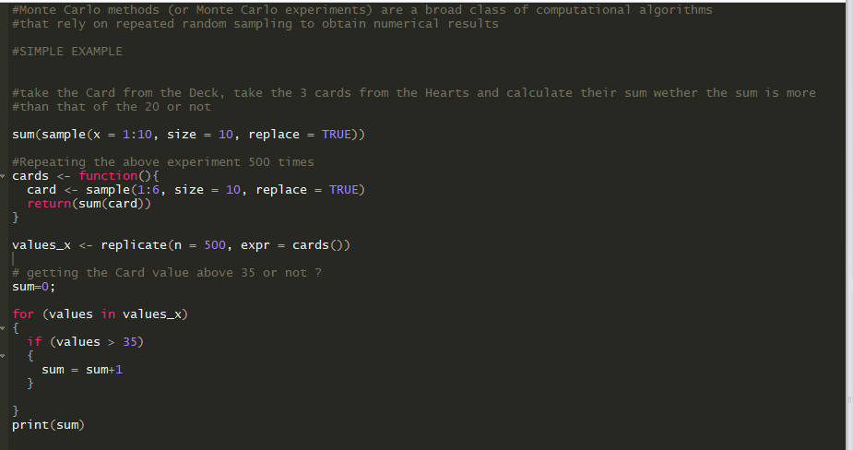

Getting the result from the simulation we get the sum of the cards above 35 are:-

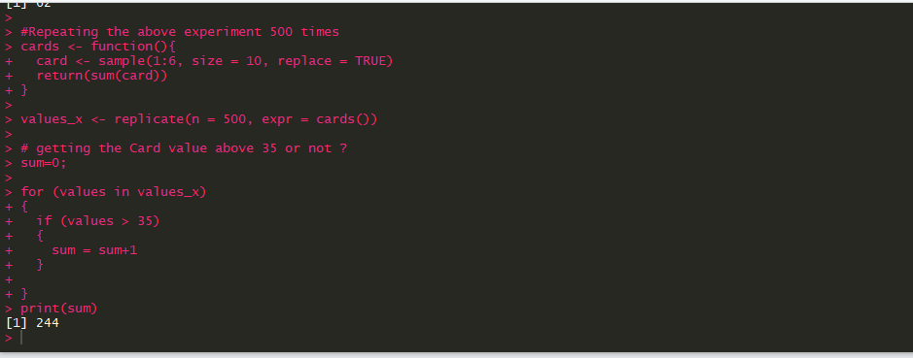

So, the count of the cards above 35 is with 500 simulations is 244.

**Conclusion**

As we have developed a model which will tell about the general profit the guy has made over the repeated simulation as the count of the cards above 35 is with 500 simulations is 244. The Guy has to give him 5$ for each of the values over 35 in this way guy can make 244*5 = 1220 dollars. IN this problem stake holder which is that Guy will make around 1220 dollars from the cards shuffle.

**Problem Statement.**

Company associate pvt ltd wants to know how profitable it will be to market their new gadget, realizing there are many uncertainties associated with market size, expenses, and revenue Getting the values from the previous trends and needs to calculate the Monte Carlo Simulation to estimate profit and evaluate risk.

**Model.**

For the Monte Carlo Simulation, we are going to use a top-down approach to create the sales forecast model, starting with: Profit = Income – Expenses.

Both income and expenses are uncertain parameters.

We'll say that Income comes exclusively from the Sales (S) increased by the benefit per Sale (P) coming about because of an individual buy of a contraption, so Income = S*P. The benefit per deal considers the deal value, the underlying expense to producer or buy the item discount, and other exchange charges (Mastercard’s, shipping, and so on.). For our motivations, we'll say the P may fluctuate amongst $47 and $53.

The number of sales per month is the number of leads per month (L) multiplied by the conversion rate (R) (the percentage of leads that result in sales). So our final equation for Income is: Income = L*R*P

We'll view the Expenses as a mix of settled overhead (H) in addition to the aggregate cost of the leads. For this model, the cost of a solitary lead (C) changes amongst $0.20 and $0.80. In light of some statistical surveying, Company associate pvt ltd expects the quantity of leads every month (L) to fluctuate in between 1200 to 1800. Our last model for Company associate pvt ltd business forecast is:

**Simulation.**

Created a simulation model in Excel based on the given inputs and generated the profit and also simulates the iterations.

For this example, we're going to use a Uniform Distribution to represent the four uncertain parameters.

The table below uses "Min" and "Max" to indicate the uncertainty in L, C, R, and P. To generate a random number between "Min" and "Max

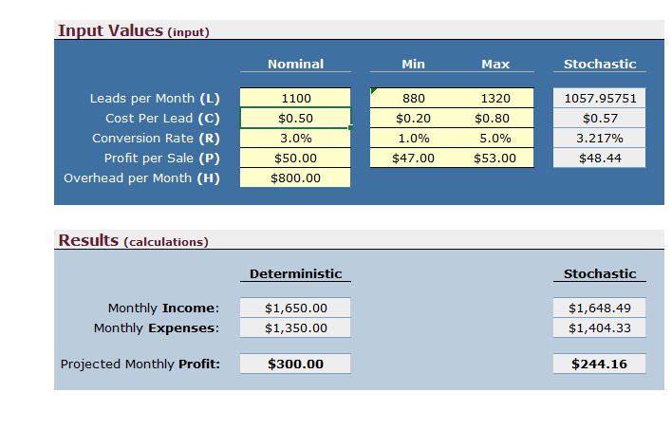

For the Monte Carlo Simulation, we have used the formulated excel for the profit of the company and how much time it will take to finally come in the profit; -

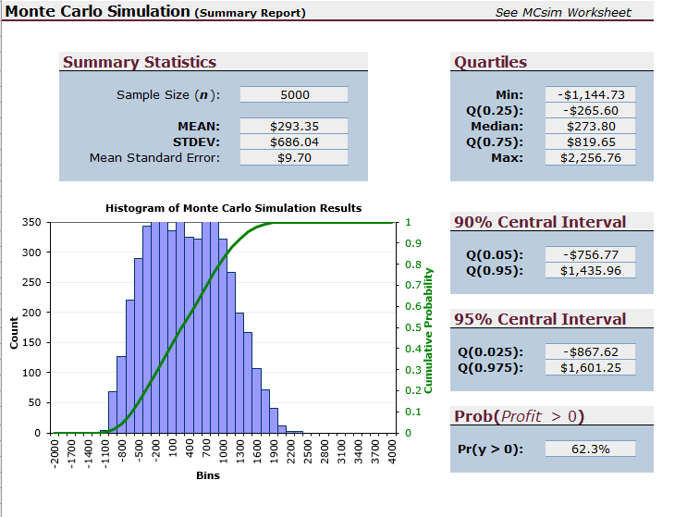

Simulated the model for 500 times so the snap of the result for the iteration of 500 times is

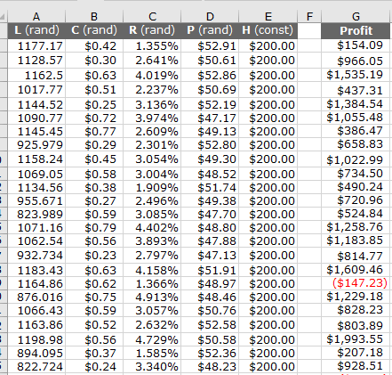

Although we still need to analyze the data, we have essentially completed a Monte Carlo simulation.

**Conclusion**

As we have developed a model which will tell about the general profit Company associate pvt ltd has made over the repeated simulation with 500. As we can see the profit chances with the simulation is over 62% by providing the values from 800 to 1200 and nominal is 1100 with the constant or the fixed expense of 800$. By this the associate pvt ltd can conclude that the chances of making the money is 62% and can make the business decision according the to the generated model.